SCREENSHOTS OF TRANSFORMATIONS:

STAGE 1: CLEANSISING OF INPUT CSV FILES:

1. TPC W

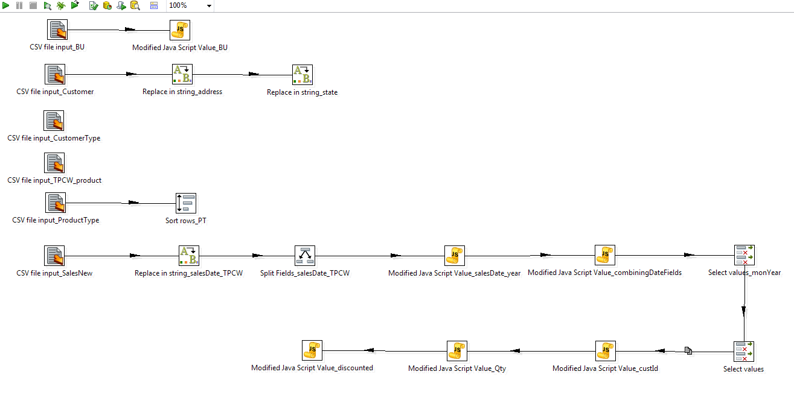

1. TPC E

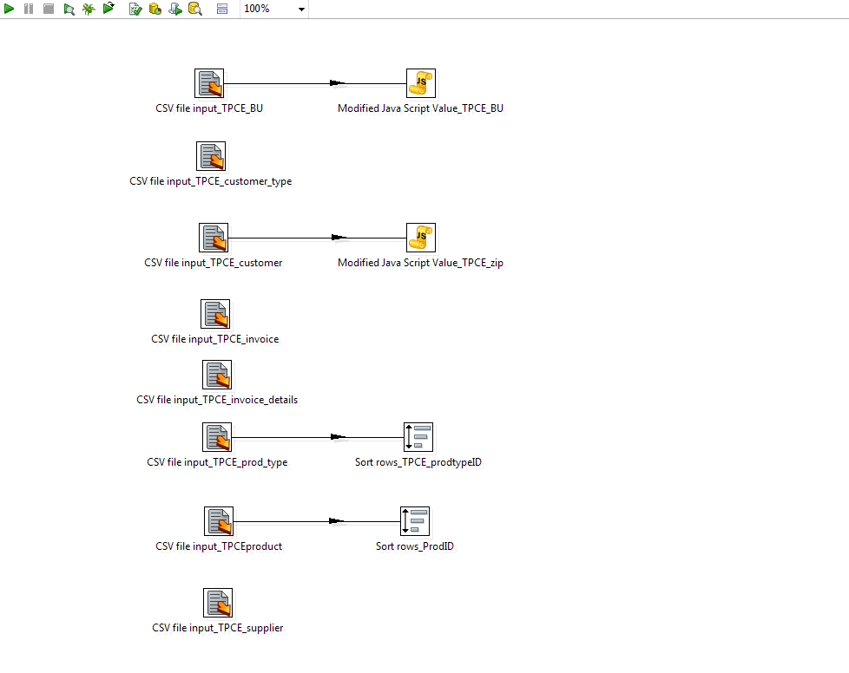

1. PEC

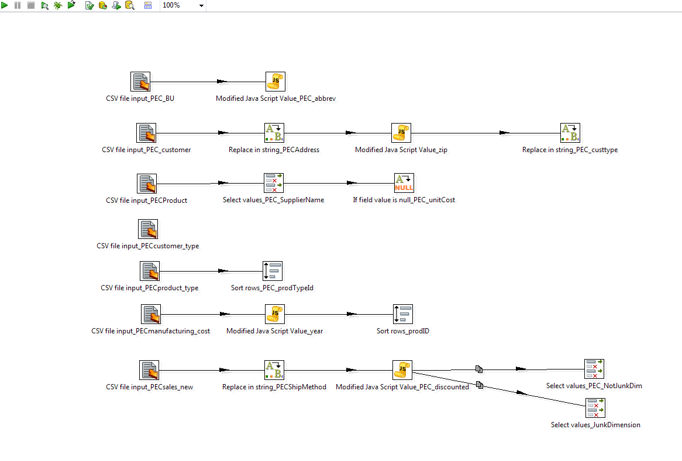

STAGE 2: STAGING/ MERGING/LOADING OF THE INPUT CSV FILES TO MAKE DIMENSIONS:

1) TPC W

1. BUSINESS_UNIT, PRODUCT & PRODUCTYPE

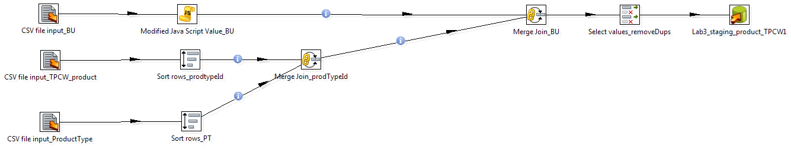

1. SALES_NEW

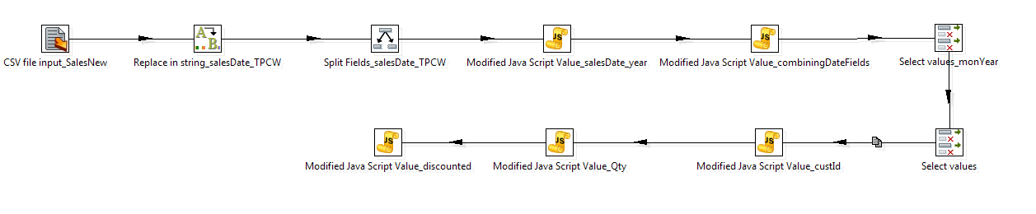

1. CUSTOMER & CUSTOMERTYPE

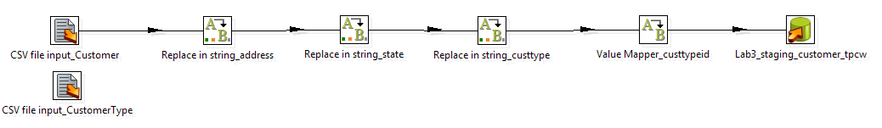

2) TPC E

1. BUSINESS_UNIT, PRODUCT & PRODUCTYPE

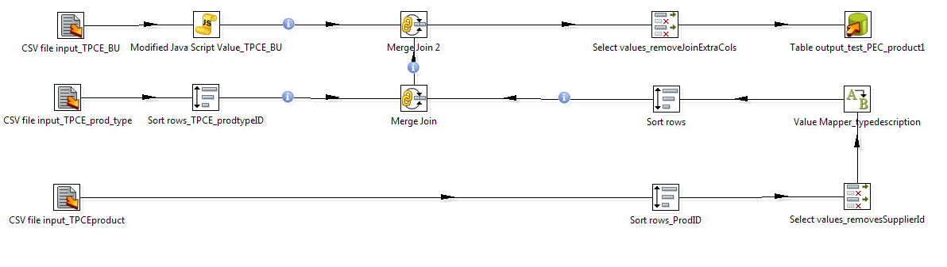

1. SUPPLIER

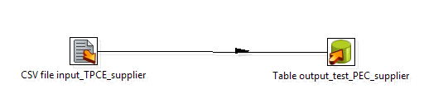

1. CUSTOMER & CUSTOMERTYPE

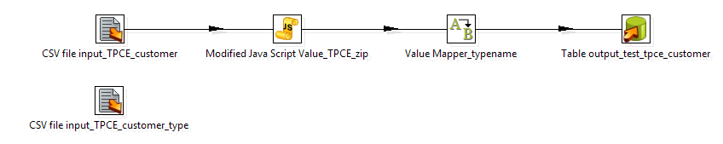

3) PEC

a) BUSINESS_UNIT, PRODUCT & PRODUCTTYPE

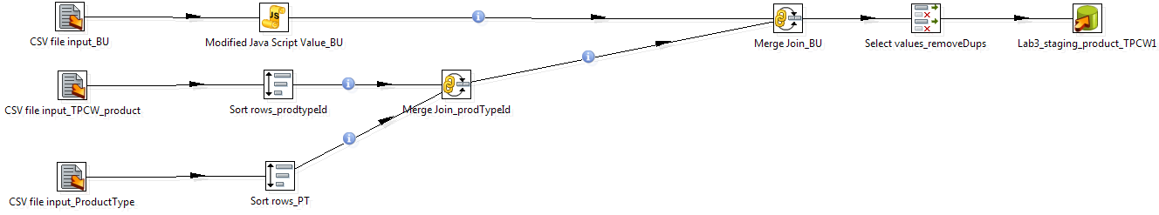

b) CUSTOMER & CUSTOMERTYPE

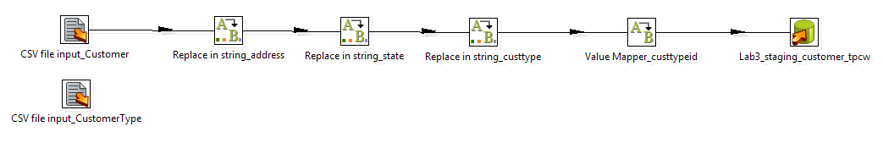

c) SALES_NEW

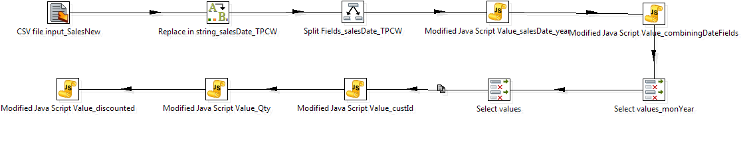

1. SALESDATE and ORDERDATE

